Network Fundamentals

Extending Your Network

Task 1:

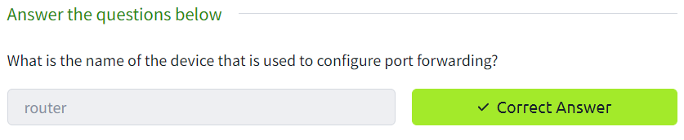

Task 2:

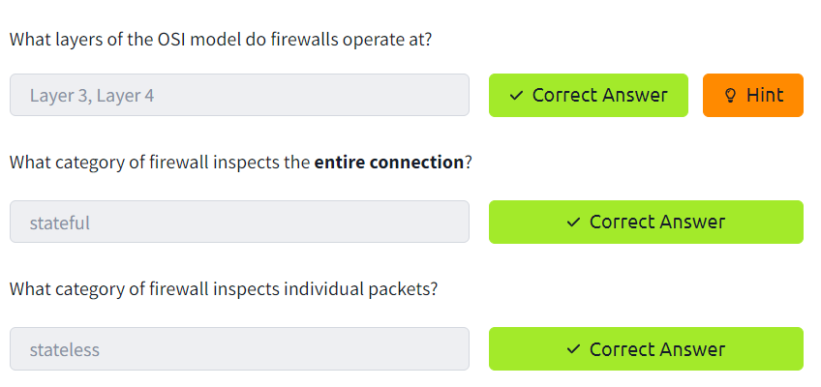

Task 3:

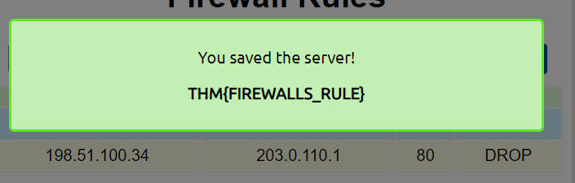



Task 4:

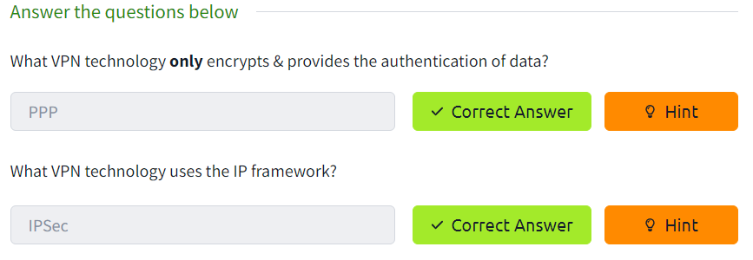

Task 4:

Task 4: